Delete any directory in the background of PHGYUN V6.4.2

[Entity Description]

The PHP Cloud Talent System is designed and developed specifically for Chinese users, with 100% open source code. It is an efficient talent and enterprise recruitment and hiring solution built on PHP and MySQL databases, which can greatly meet the needs of webmasters for secondary development of website programs while respecting copyright.

[Vulnerability Description]

There are no restrictions on user input, resulting in the ability to delete any folder across directories.

[Impact Description]

Attackers can delete important files and directories in applications and systems, resulting in data loss or irreparable damage. By deleting critical system files or directories, attackers can cause applications or the entire system to malfunction, resulting in service interruptions.

[Physical download address]

https://www.phpyun.com/bbs/thread-17296-1-1.html

admin/model/database.class.php

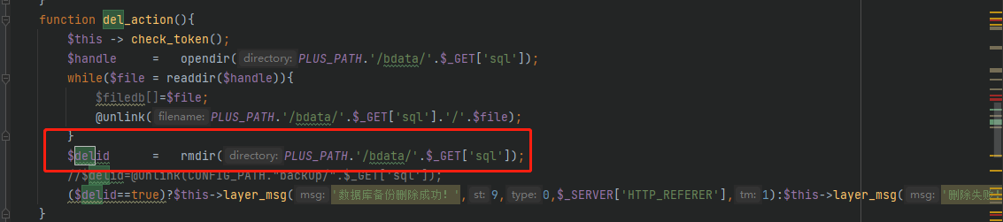

Accessing the backend

http://localhost/admin/index.php

Log in using admin admin

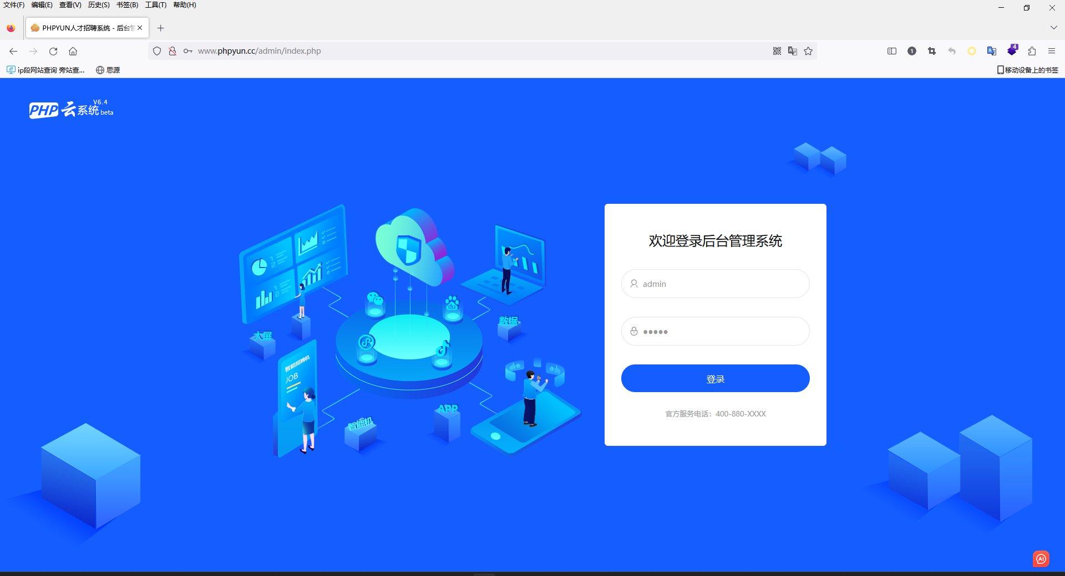

Click on a few backend functions and search for pytoken in history

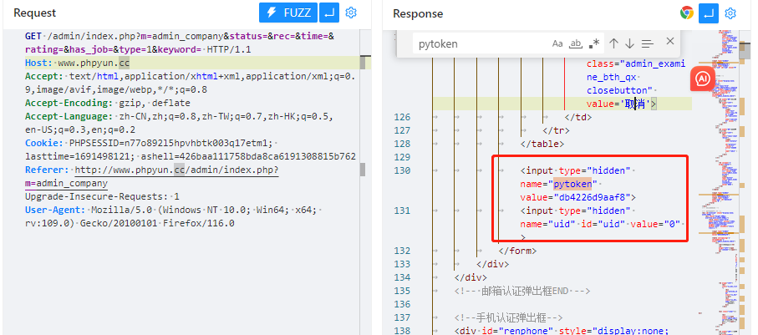Construct data package to delete test directory

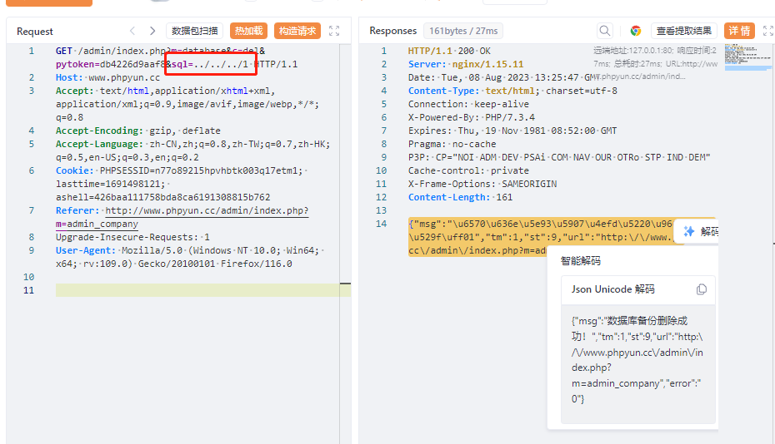

The folder 1 in the root directory of the website has been deleted